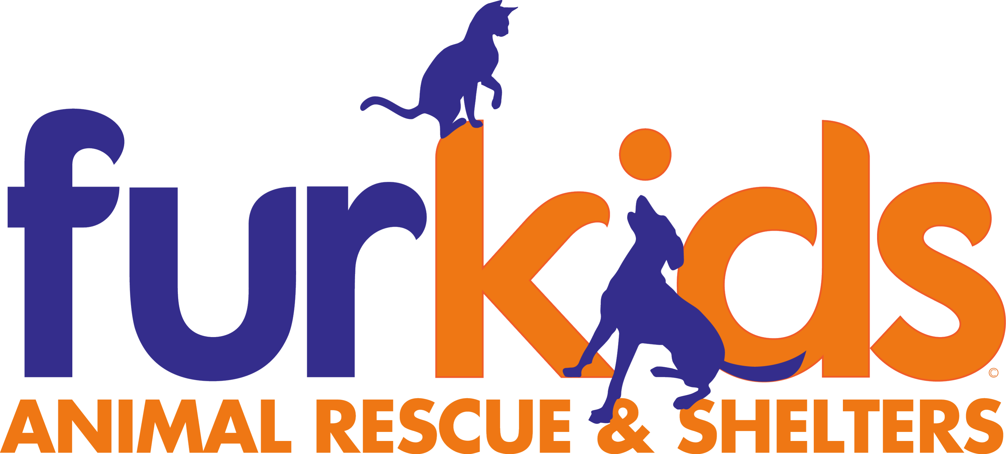
JOB TITLE: Veterinary Practice Manager
FULL TIME/PART TIME: FULL TIME
REPORTS TO: Chief Medical Officer
LOCATION: Furkids Medical Center, Cumming, GA
SALARY: $55,000 – 70,000

ABOUT FURKIDS
Founded in 2002, Furkids has grown into the largest no-kill, cage-free animal sheltering organization in the Southeastern United States, serving an average of 5,000 cats and dogs each year through adoption, foster, and rescue programs across the greater Atlanta metro area.
POSITION SUMMARY
The Veterinary Practice Manager is responsible for the day-to-day administrative and operational management of Furkids' veterinary medical services. This role ensures the medical center runs efficiently, safely, and in compliance with applicable regulations, allowing veterinarians and medical staff to focus on animal care. Reporting to the Chief Medical Officer, the Practice Manager oversees non-clinical operations including inventory and supply chain management, facilities coordination, scheduling systems, medical records administration, budget tracking, and vendor relationships. This position plays a key role as Furkids transitions into its new 12,000 square foot medical center and expands its clinical programs.
PRIMARY RESPONSIBILITIES
Inventory & Supply Chain Management
- Oversee ordering, receiving, and tracking of all medical supplies, pharmaceuticals, and equipment.
- Maintain accurate inventory records and implement systems (manual or software-based) to prevent stockouts and overstock.
- Monitor controlled substance inventory and logs in compliance with DEA and state veterinary board requirements.
- Negotiate pricing and terms with medical supply vendors and evaluate vendor performance regularly.
- Conduct periodic physical inventory counts and reconcile against records; investigate and resolve discrepancies.
- Manage expiration date tracking and coordinate proper disposal of expired or unusable medications and supplies.
Practice Operations & Administration
- Manage day-to-day administrative operations of the medical center, including front-desk workflows, scheduling systems, and client/adopter communication processes.
- Develop and maintain standard operating procedures (SOPs) for administrative and clinical support functions.
- Ensure facility compliance with OSHA, state veterinary practice regulations, and Furkids' internal safety policies.
- Coordinate facilities maintenance requests and manage relationships with building/equipment service vendors.
- Oversee medical records systems, ensuring accuracy, confidentiality, and regulatory compliance.
- Support the Chief Medical Officer with data reporting on clinical volume, capacity, and operational metrics.
Budget & Financial Administration
- Assist in developing and monitoring the annual medical department budget in partnership with the Chief Medical Officer and Finance team.
- Track medical department spending against budget and flag variances.
- Process invoices, purchase orders, and expense reports related to medical operations.
- Support grant reporting and program budgeting for medical initiatives (e.g., spay/neuter programs, CatSnip events).
Staff Support & Coordination
- Coordinate non-clinical staff scheduling to ensure adequate administrative and support coverage across shifts and locations.
- Supervise, train, and evaluate administrative/support staff, including front desk, inventory, and medical records personnel.
- Serve as a liaison between administrative staff and clinical staff to ensure smooth day-to-day operations.
- Support onboarding of new medical support staff and volunteers, including training on administrative systems and protocols.
Compliance & Risk Management
- Maintain up-to-date licensure, certification, and regulatory records for the medical facility.
- Ensure compliance with state veterinary practice act requirements applicable to the facility.
- Support incident reporting and risk management processes related to facility operations, animal handling, and workplace safety.
- Maintain relationships with external partner clinics and vendors, ensuring referral and supply agreements remain current.
REQUIRED QUALIFICATIONS
- Bachelor's degree in business administration, healthcare administration, or related field preferred; equivalent practice management experience considered in lieu of degree.
- 3+ years of experience in veterinary practice management, medical office administration, or a related healthcare operations role.
- Experience with veterinary practice management software (e.g., Cornerstone, Avimark, ImproMed, or similar) and inventory management systems.
- Working knowledge of controlled substance handling and recordkeeping requirements.
- Strong organizational, budgeting, and vendor negotiation skills.
- Experience supervising staff preferred.
- Nonprofit or animal welfare experience a plus, but not required.
- Excellent written and verbal communication skills; ability to work cross-functionally with clinical and administrative teams.
- Ability to work in a clinical/shelter environment with exposure to animals, animal waste, and cleaning/medical chemicals.
- Ability to lift up to 25-40 lbs (e.g., supply boxes, equipment).
- Ability to sit, stand, and move throughout the facility for extended periods.
SALARY AND BENEFITS
- Salary: TBD
- Health Insurance
- Dental Insurance
- Retirement Plan
- Paid Time Off

To apply, please send your resume to Samantha Shelton jobs@furkids.org.

