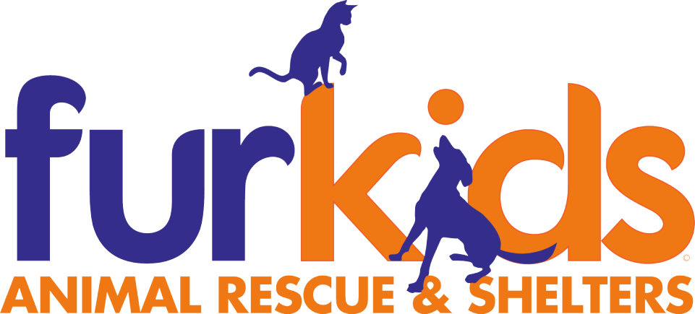
Chief Medical Officer (CMO)
Full Time/Part Time: Full Time
Reports To: Chief Executive Officer
Location: Furkids Headquarters – Giaquinto Medical Center, 5235 Union Hill Road, Cumming, GA
Salary: $150,000 – 200,000

About Furkids
Founded in 2002, Furkids has grown into the largest no-kill, cage-free animal sheltering organization in the Southeastern United States. What began as a grassroots effort to save homeless cats has evolved into a comprehensive, multi-facility network that rescues, rehabilitates, and rehomes more than 5,000 cats and dogs each year. Furkids now operates state-of-the-art shelters, a thriving medical clinic, adoption centers, and multiple thrift stores whose proceeds help sustain the mission. With nearly 100 staff members and over 1,000 dedicated weekly volunteers, Furkids is a recognized leader in life-saving animal welfare, community engagement, and compassionate care. The organization's mission is rooted in giving every adoptable animal the chance to live, love, and thrive in a permanent home.

Position Summary
Furkids is seeking an experienced, confident, and highly collaborative Chief Medical Officer (CMO) to lead the strategic direction, quality of care, and clinical excellence of our medical programs. This executive-level role oversees veterinary operations across the organization, including the new Giaquinto Medical Center and shelter medical care, ensuring consistent standards, outstanding patient care, and alignment with Furkids' mission.
The CMO will guide veterinarians, veterinary technicians, medical staff, and volunteers; develop and implement medical protocols; lead disease control and population health strategies; and champion innovation in shelter medicine. This leader will also support growth initiatives, build meaningful external partnerships, and represent Furkids as a respected voice within the veterinary and shelter medicine communities.
The ideal candidate is a compassionate and confident medical leader with strong executive presence, excellent clinical knowledge, proven leadership experience, and a deep commitment to life-saving work. Occasional after-hours emergency leadership support may be required.

Primary Responsibilities
Medical Leadership & Strategy
- Provide executive leadership and direction for all Furkids veterinary and medical programs, including the Giaquinto Medical Center and organizational shelter medical operations
- Establish, refine, and maintain medical protocols, standards of care, and best-practice guidelines in alignment with Furkids' mission and values
- Serve as the senior medical authority, partnering with the CEO on complex medical decisions and organizational medical philosophy
- Promote a culture of excellence, compassion, accountability, and innovation in shelter medicine
Clinical Oversight & Population Health
- Oversee clinical care delivery, ensuring the highest standards of medical and surgical quality
- Lead organization-wide disease control programs, including infection prevention measures and outbreak response leadership
- Oversee shelter population health strategy to promote wellness, reduce illness, and support positive outcomes
- Support high-quality shelter medicine practices, including preventative care and treatment planning
Leadership & Team Development
- Provide leadership, mentorship, and direct support to veterinarians, veterinary technicians, medical staff, and volunteers involved in medical care
- Participate in recruitment, hiring, onboarding, performance oversight, and professional development for medical team members
- Foster a collaborative, supportive, and educational environment that encourages learning, growth, and excellence
- Uphold a positive leadership culture that supports teamwork, communication, and shared mission focus
Operations, Compliance & Quality Assurance
- Oversee controlled substances compliance, DEA requirements, and proper medication control and documentation
- Ensure state and federal veterinary regulations, licensing, and legal standards are met across medical programs
- Oversee medical record integrity, accuracy, and consistency in documentation practices
- Support ongoing quality assurance efforts and continuous improvement in medical operations
- Provide occasional after-hours leadership support for urgent medical situations
Partnerships, Collaboration & Community Impact
- Build and strengthen partnerships with veterinary schools, universities, rescue partners, and shelter medicine leaders
- Represent Furkids within professional networks, thought leadership forums, and relevant industry conversations
- Serve as a respected ambassador of Furkids' medical excellence and compassionate mission when appropriate
Budgeting & Resource Stewardship
- Manage comprehensive medical budget including resource planning, equipment strategy, and inventory management
- Support responsible and strategic use of medical resources to ensure operational sustainability and high-quality care
- Help evaluate future medical needs and organizational growth planning

Required Qualifications
- Doctor of Veterinary Medicine (DVM/VMD) from an accredited university
- Active Georgia veterinary license or ability to obtain promptly
- Extensive professional veterinary experience, preferably including shelter medicine or comparable high-volume medical environments
- Demonstrated leadership experience managing veterinary teams and medical operations
- Strong expertise in population health, disease control, and shelter medical care best practices
- Proven ability to lead teams, manage complex responsibilities, and inspire professional excellence
- Exceptional communication, collaboration, problem-solving, and organizational skills
- Deep commitment to animal welfare and alignment with Furkids' no-kill values

Salary & Benefits
- Salary commensurate with experience
- Health insurance
- Dental insurance
- Retirement plan
- Paid time off
- Opportunity to lead a premier medical program and shape the future of life-saving animal care in the Southeast
Thank you for your interest in pursuing a meaningful and impactful leadership career with Furkids Animal Rescue and Shelters.
To apply or inquire, please contact Furkids CEO and Founder, Samantha Shelton:
Sam@furkids.org

